**Project Design Phase**

**Solution Architecture**

|  |  |
| --- | --- |
| Date | 24 June 2025 |
| Team ID | LTVIP2025TMID37335 |
| Project Name | pattern sense: classifying fabric patterns using deep learning |
| Maximum Marks | 4 Marks |

**Solution Architecture:**

Solution architecture for **Pattern Sense** bridges the gap between business needs (automated, accurate, and scalable fabric pattern classification) and technology solutions (deep learning models, image processing pipelines, scalable deployment, etc.). The goals of Pattern Sense’s solution architecture are to:

* **Find the best tech solution to solve existing business problems**

Pattern Sense leverages deep learning (specifically convolutional neural networks such as ResNet or EfficientNet) for high-accuracy image classification. It uses Python-based AI frameworks (e.g., TensorFlow, PyTorch) combined with a scalable cloud-based deployment infrastructure (AWS, Azure, or GCP) to process large volumes of fabric images efficiently.

* **Describe the structure, characteristics, behavior, and other aspects of the system to project stakeholders**

The architecture clearly outlines the data flow from raw fabric image acquisition, preprocessing (resizing, augmentation), feature extraction via CNN models, classification output, and final integration into business applications (e.g., inventory systems, design recommendation engines). Supporting modules include a model training pipeline, evaluation tools, and a feedback loop for continuous learning.

* **Define features, development phases, and solution requirements**

Key features include automatic pattern recognition (e.g., floral, geometric, abstract), confidence scoring, support for custom pattern categories, and an intuitive user dashboard for uploading and managing images. Development phases are split into dataset collection and preparation, model design and training, integration with backend APIs, dashboard development, and final testing and deployment.

* **Provide specifications according to which the solution is defined, managed, and delivered**

The architecture includes detailed model architecture diagrams, RESTful API specifications for prediction services, data storage and management guidelines (e.g., cloud object storage for images), and deployment strategies using containerization (Docker, Kubernetes) for scalability and maintainability. Monitoring and retraining pipelines are also included to ensure model performance remains high as new patterns and data emerge.

**Example - Solution Architecture Diagram:**

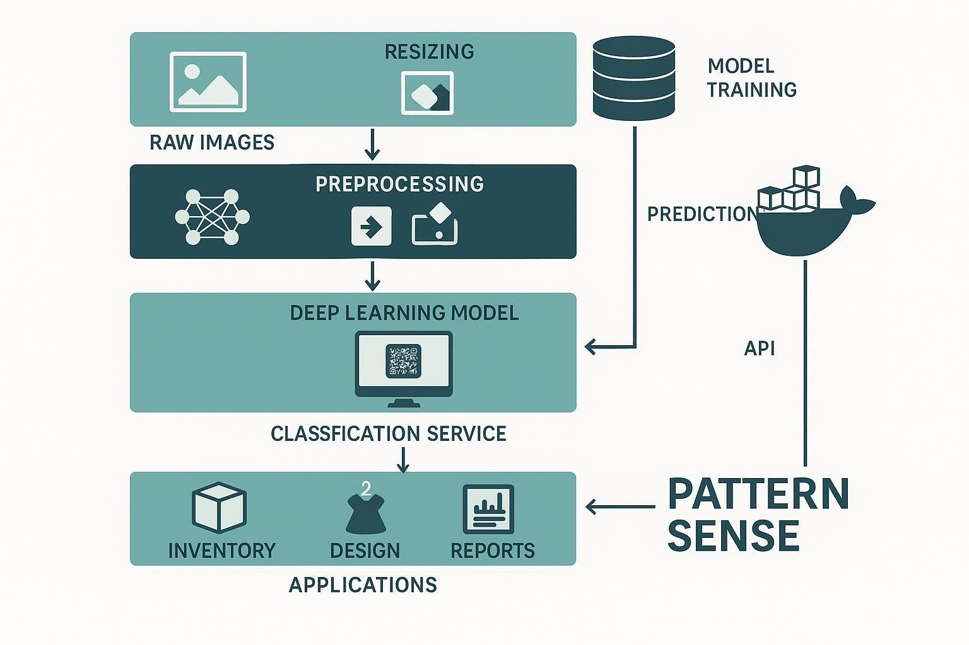

*Figure 1: Architecture and data flow of the pattern sense: classifying fabric patterns using deep learning*